**Spring boot annotations:**

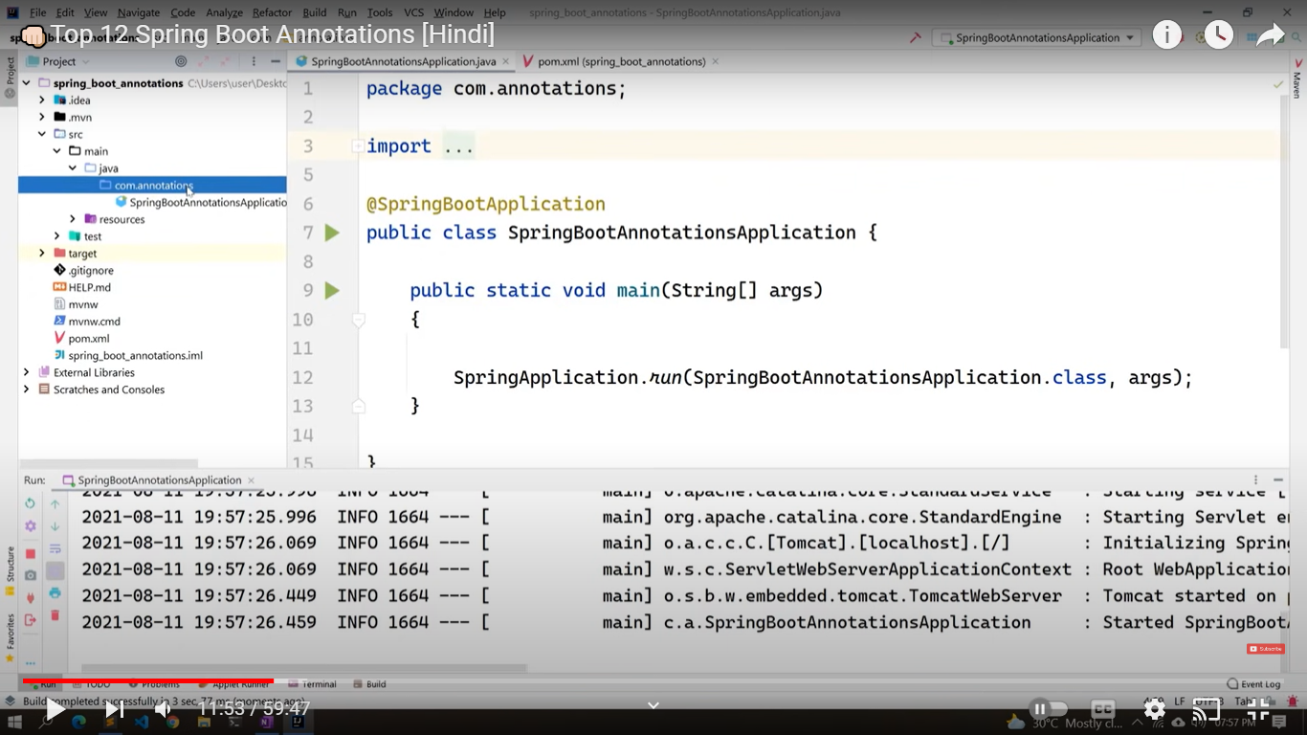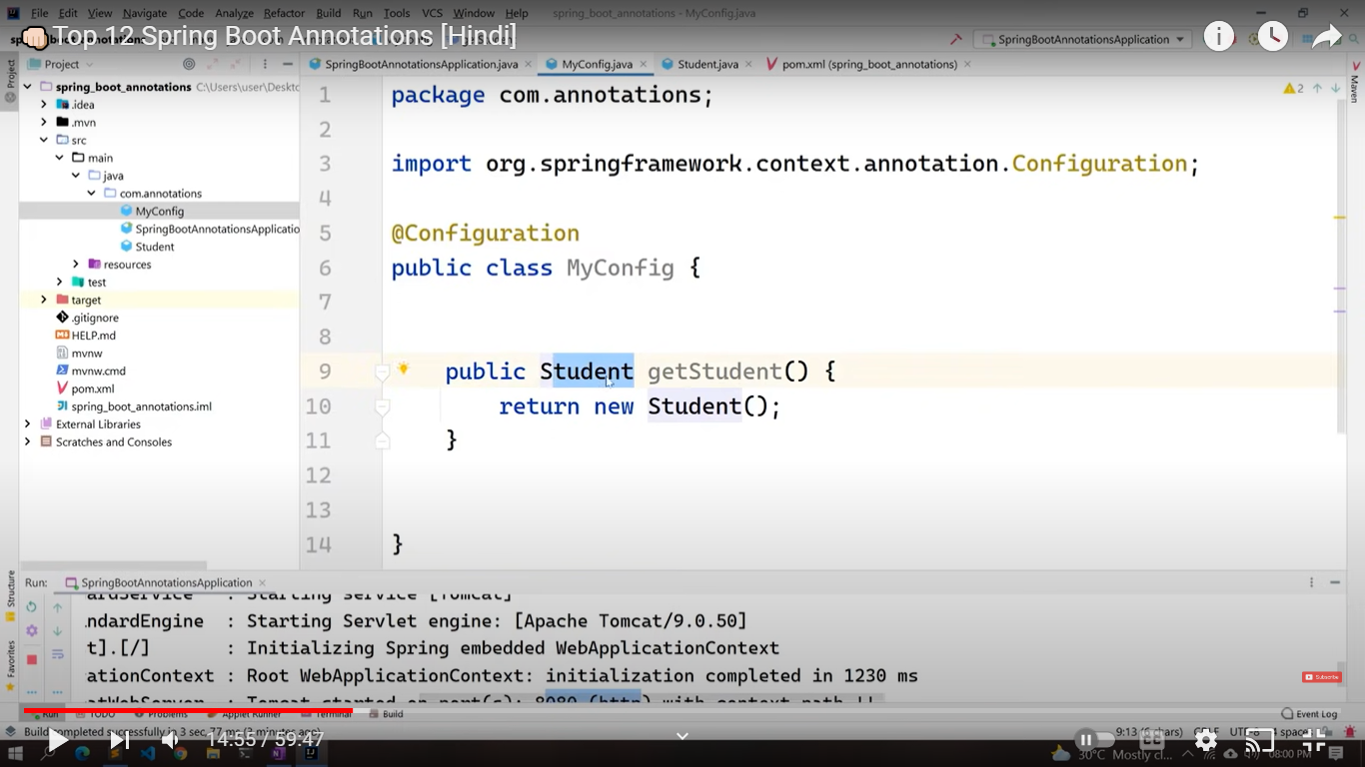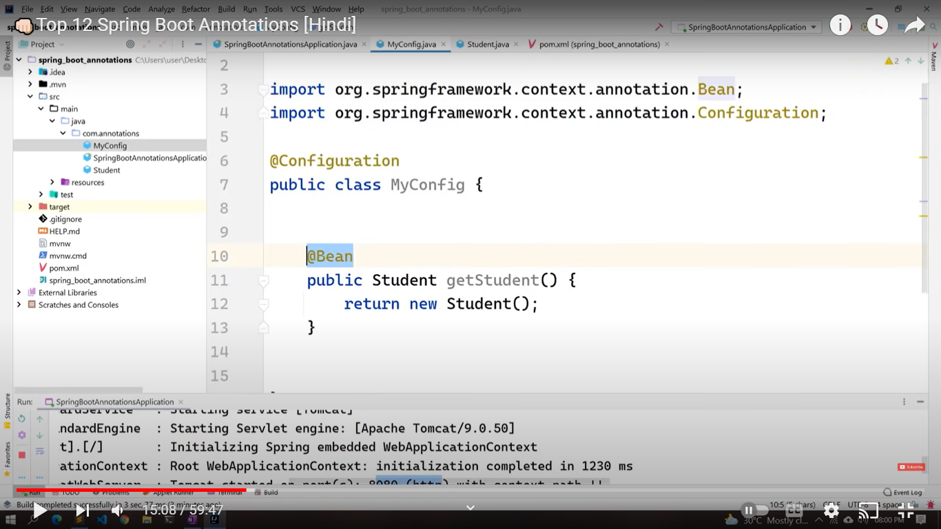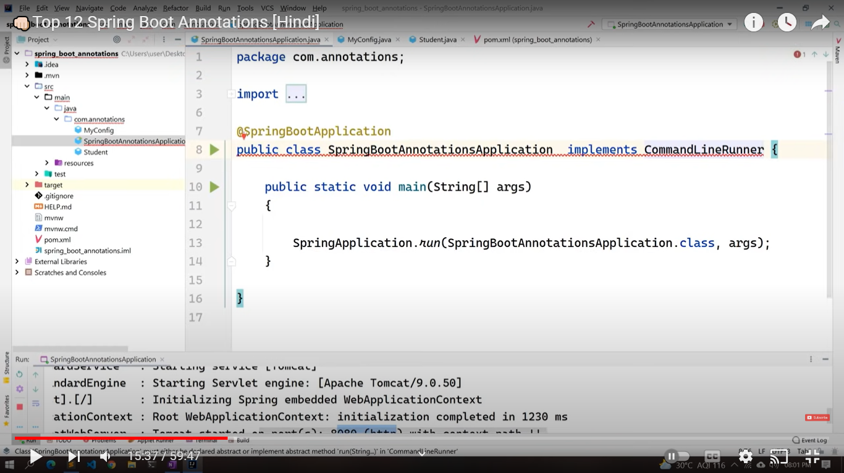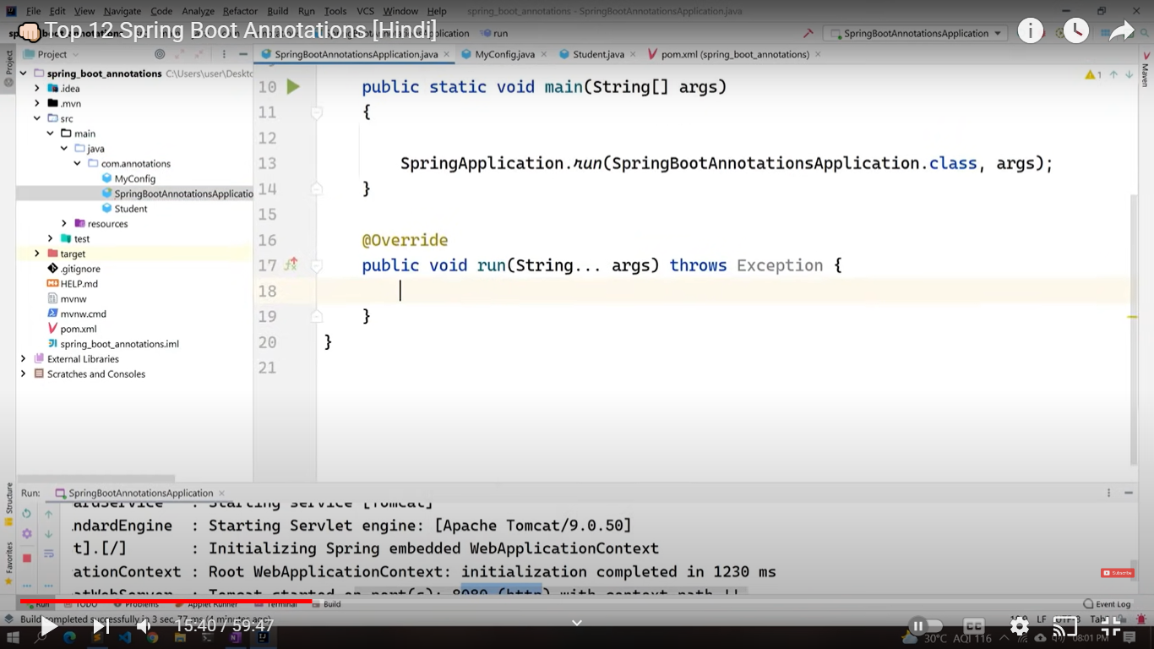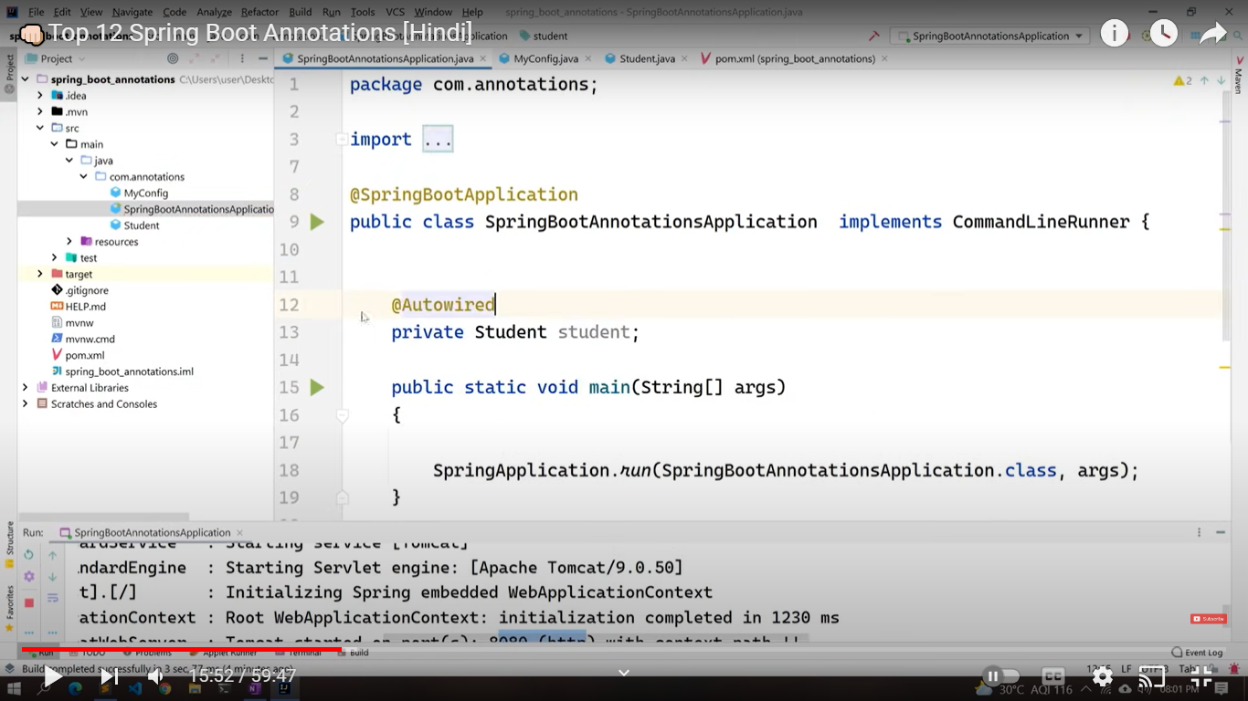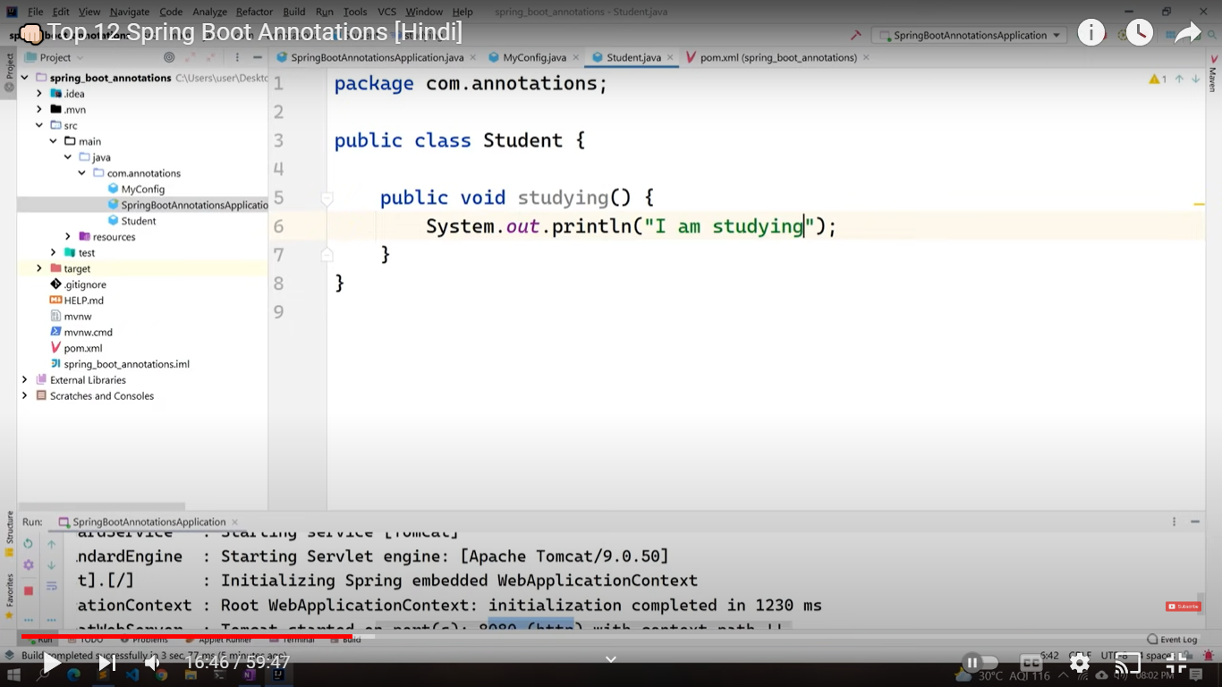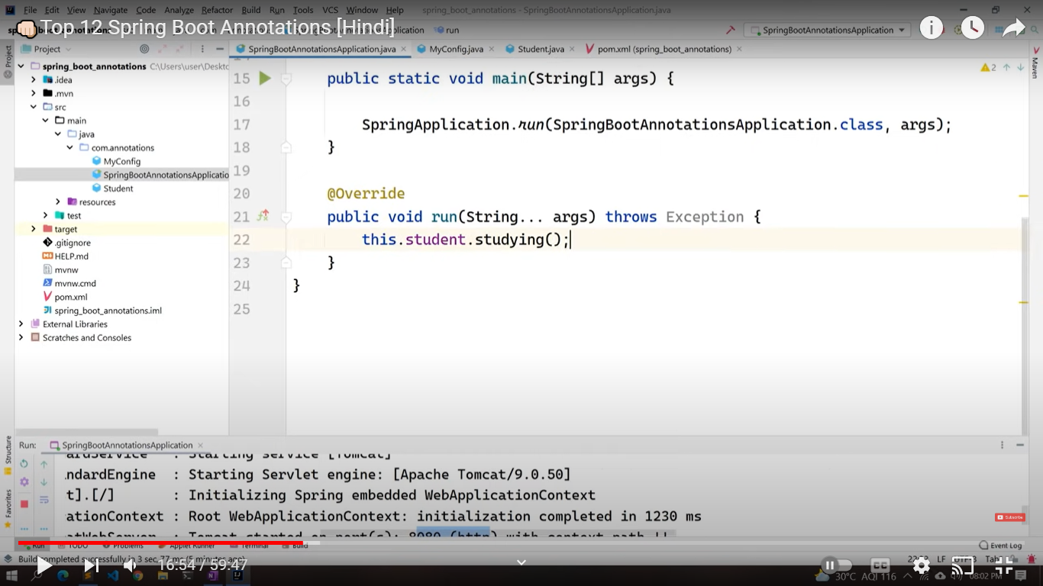

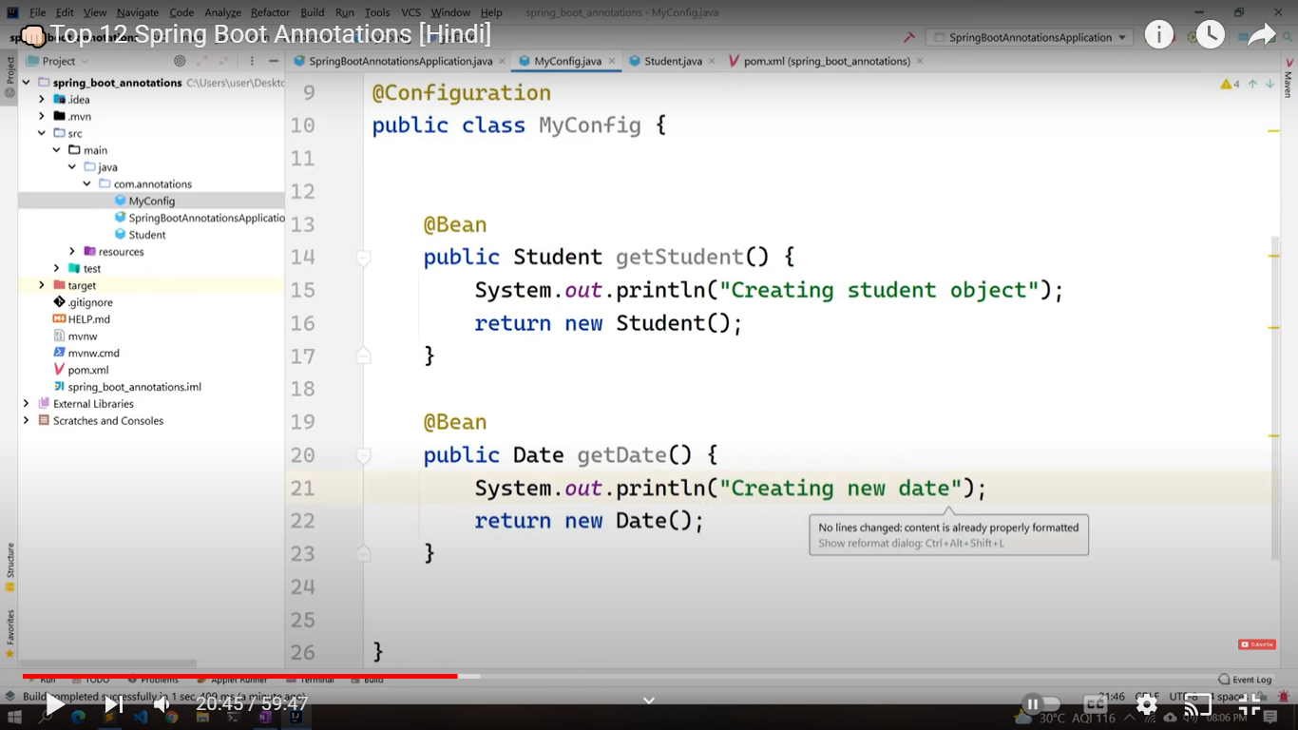

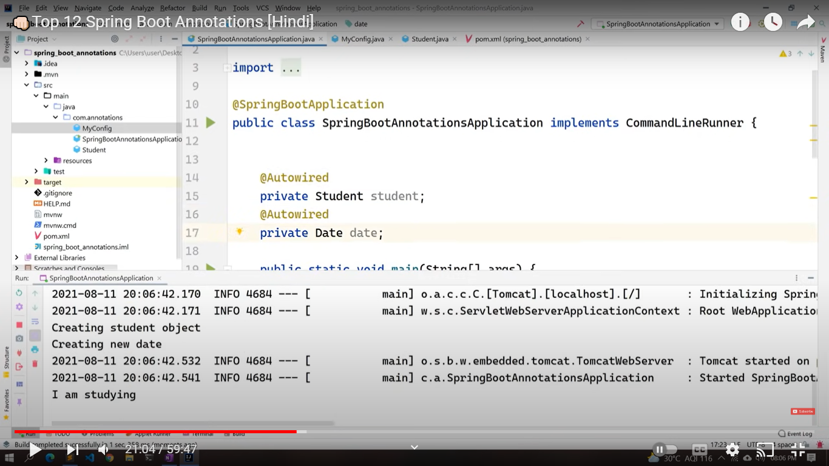

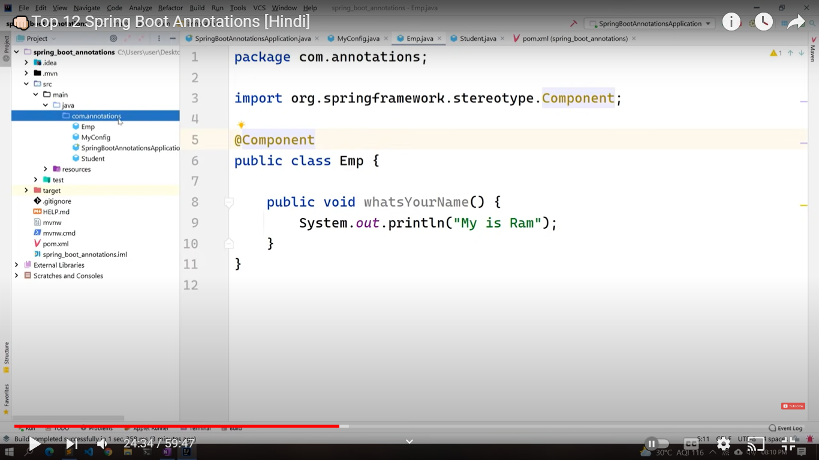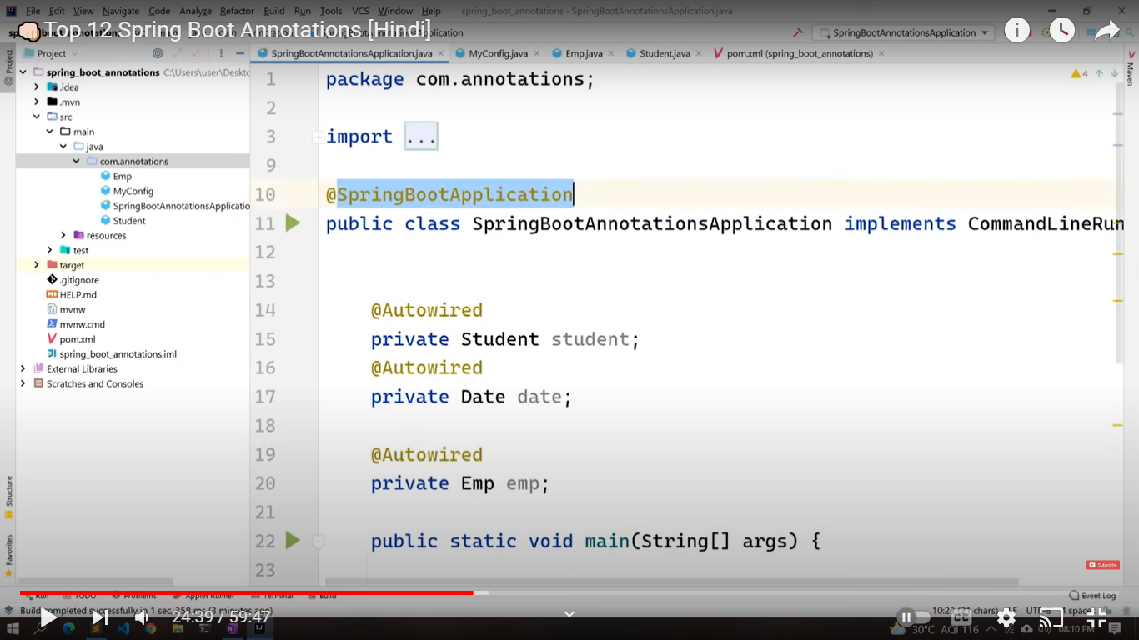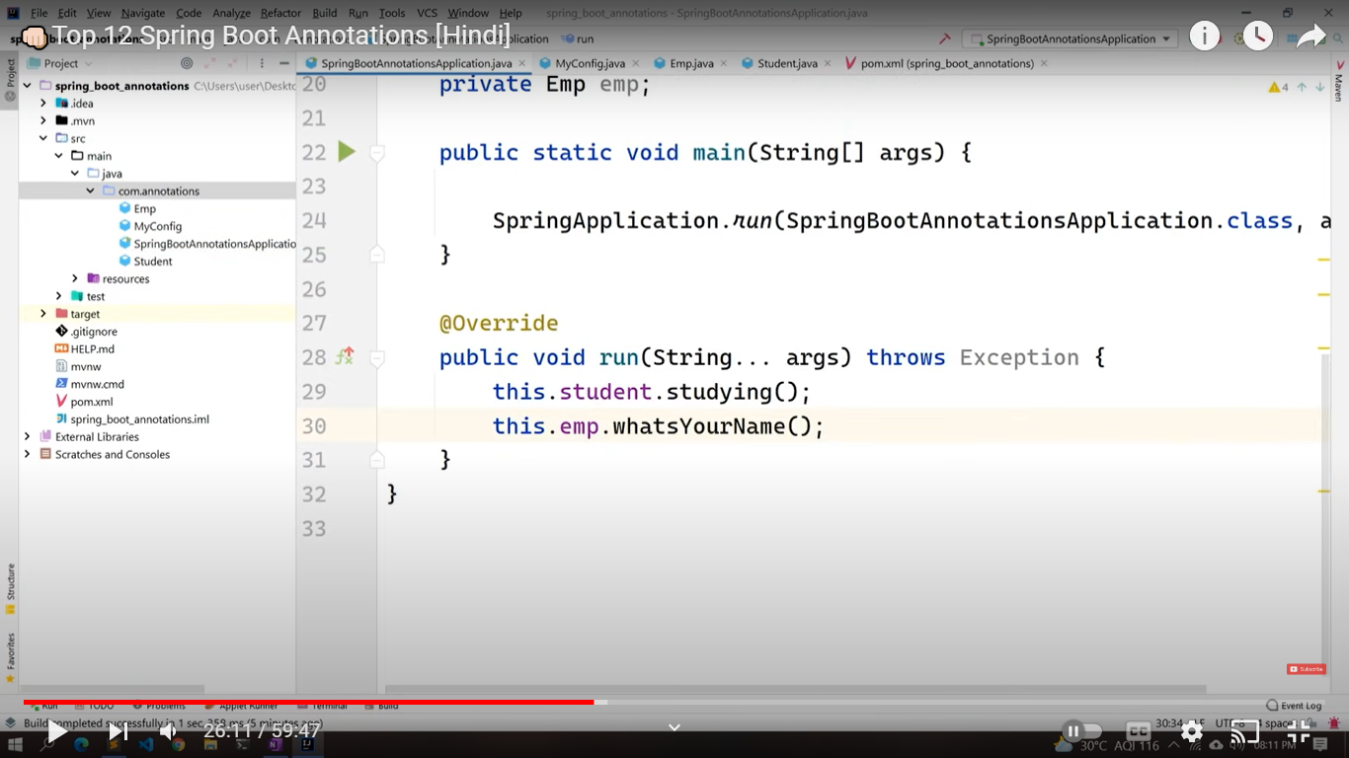

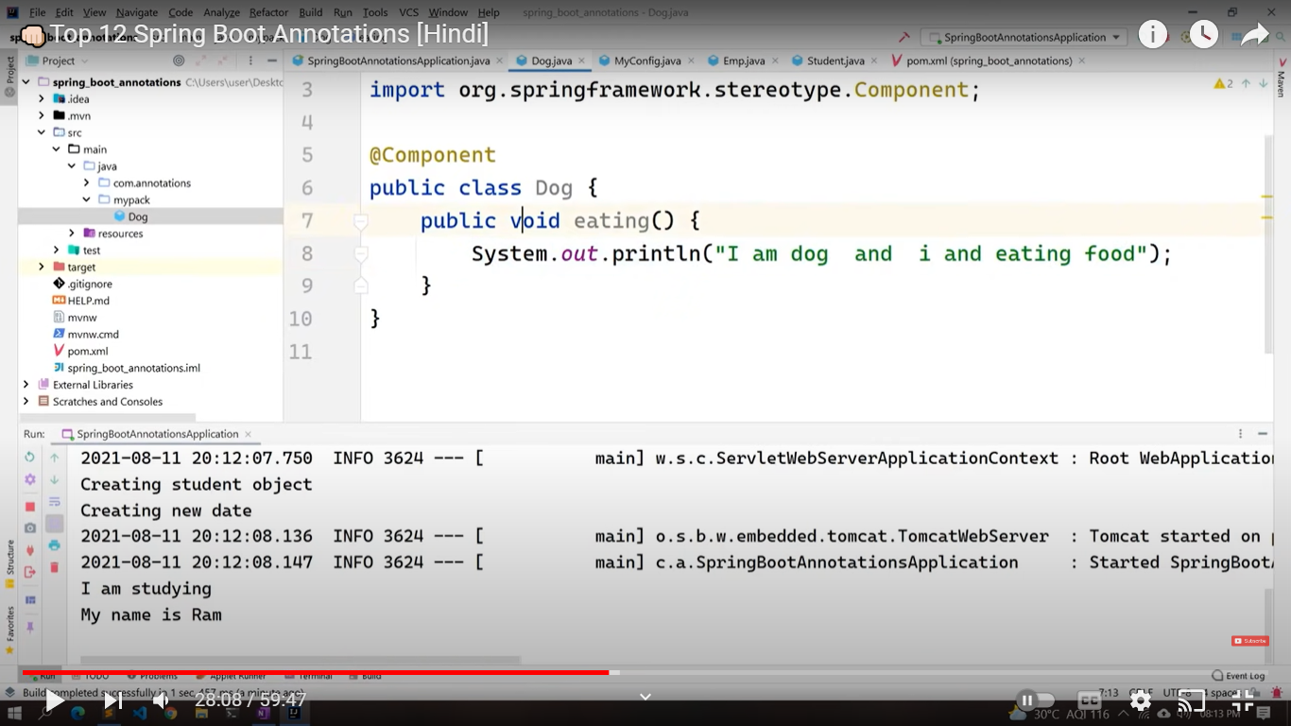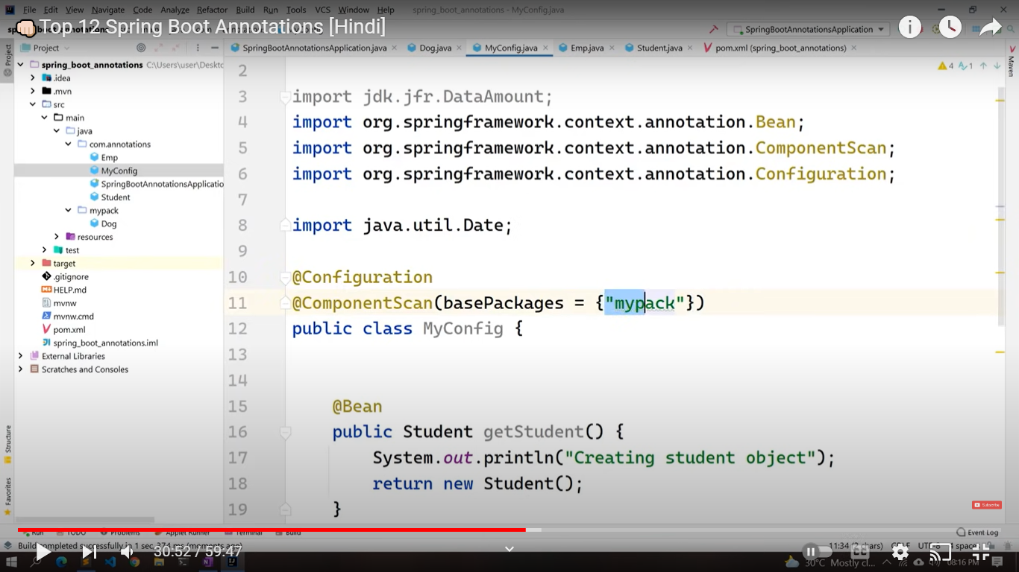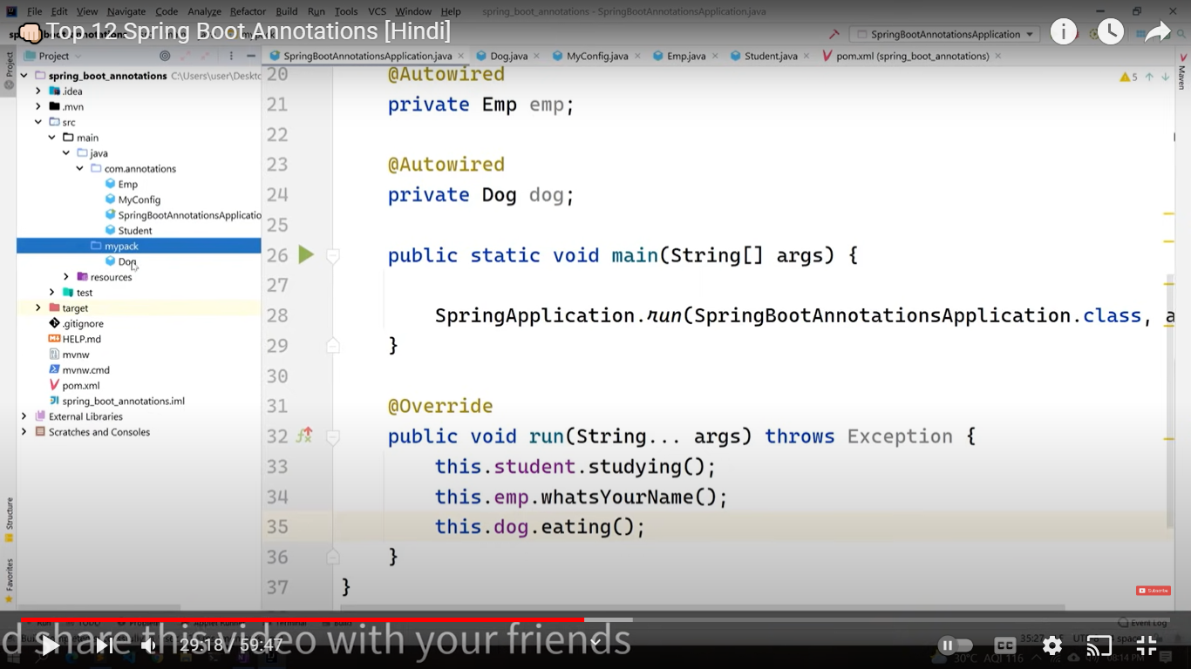

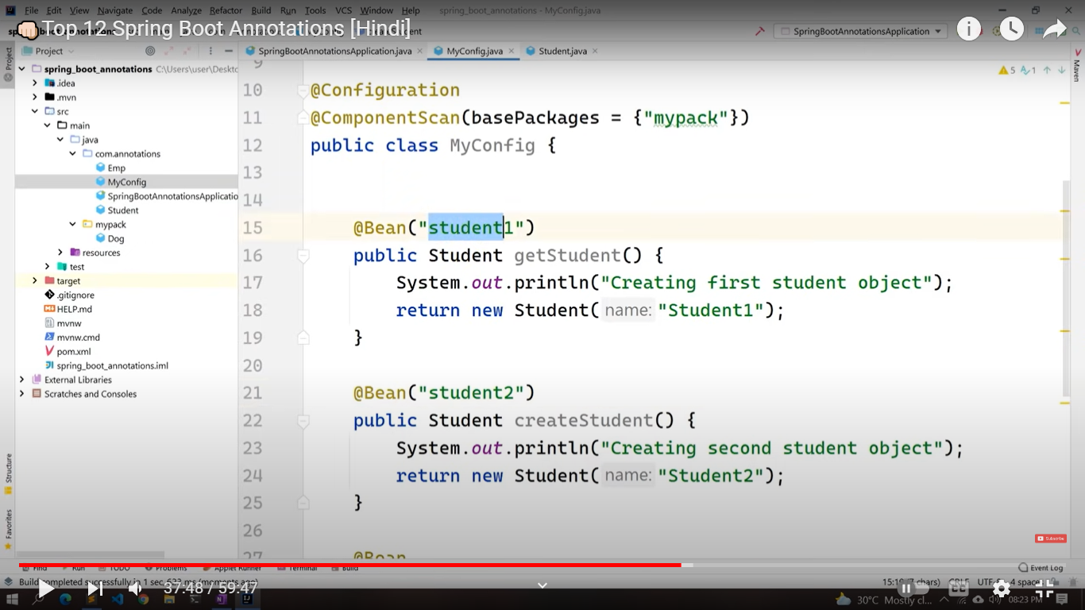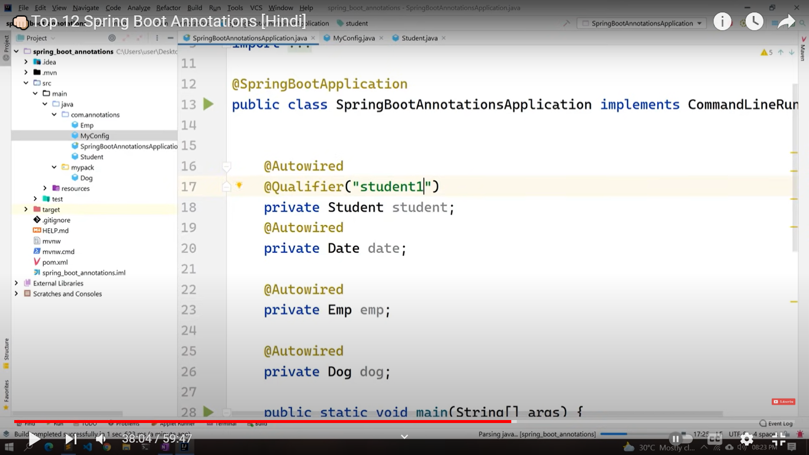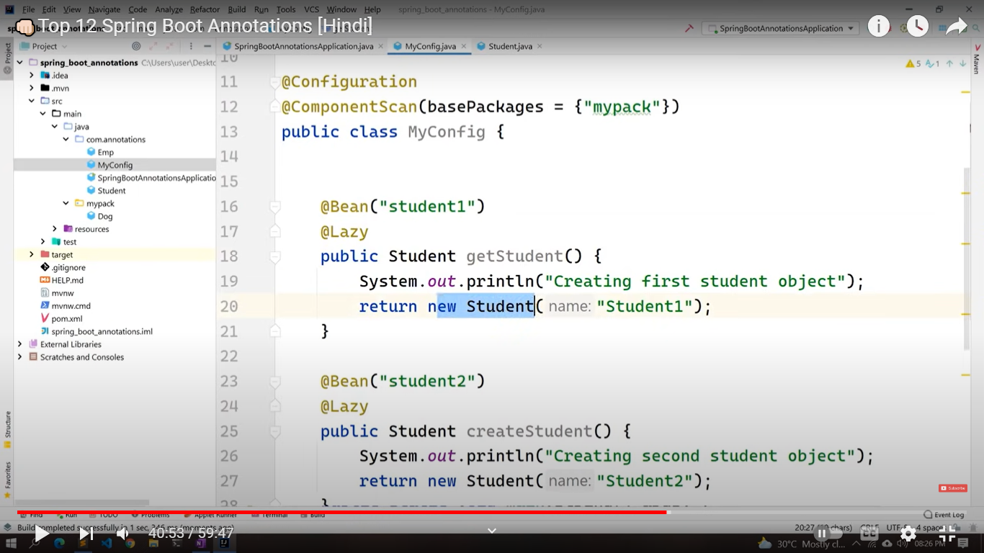

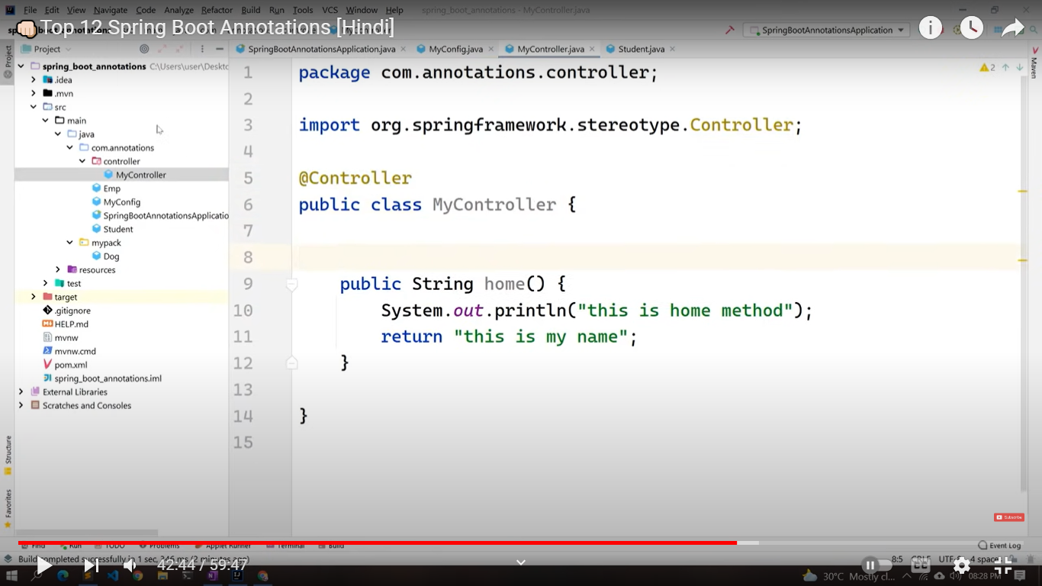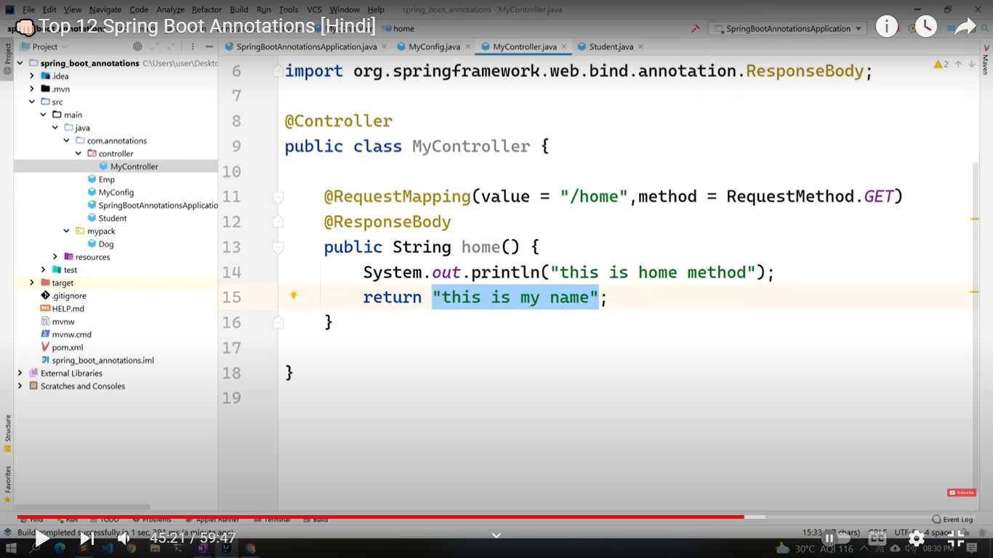

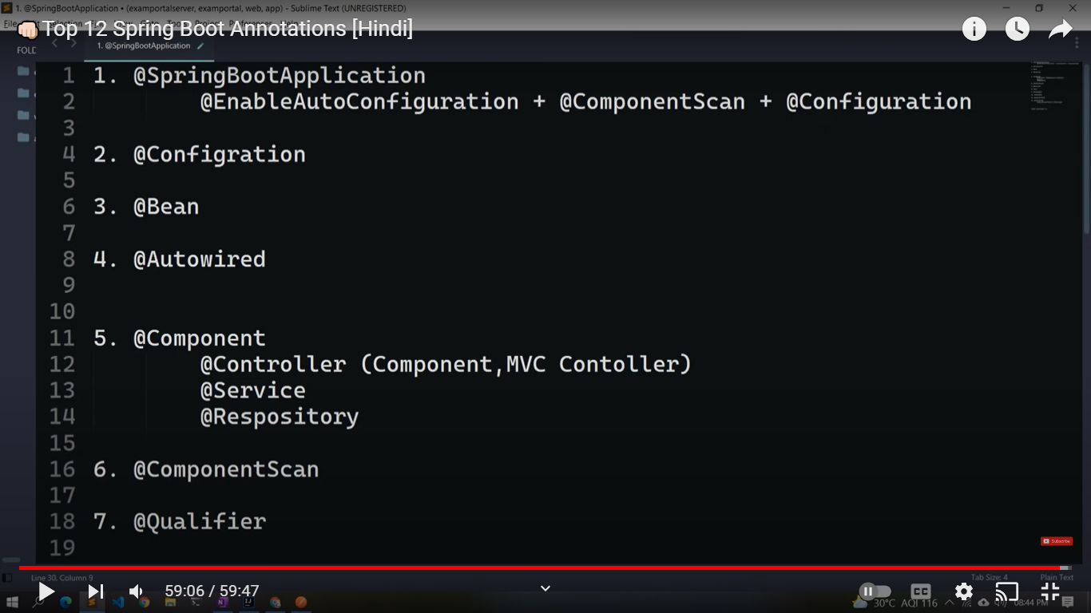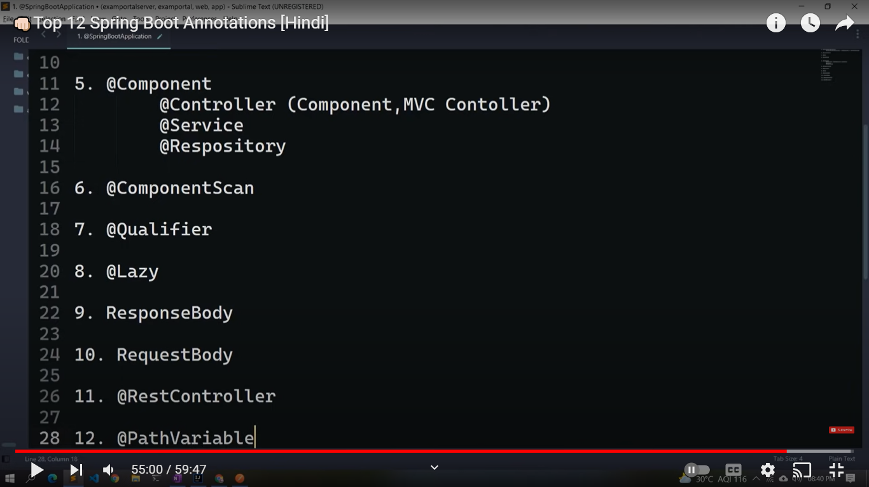

**JPA**

/// Address.java

package com.neo.model;  
  
public interface UserInfo {  
 String getUserName();  
 String getEmail();  
 String getHobby();  
 String getIntroduction();  
}

////User.java

package com.neo.model;  
  
import jakarta.persistence.Column;  
import jakarta.persistence.Entity;  
import jakarta.persistence.GeneratedValue;  
import jakarta.persistence.Id;  
  
import static jakarta.persistence.GenerationType.IDENTITY;  
  
@Entity  
public class User {  
  
 @Id  
 @GeneratedValue(strategy=IDENTITY)  
 private Long id;  
 @Column(nullable = false, unique = true, length = 30)  
 private String userName;  
 @Column(nullable = false)  
 private String passWord;  
 @Column(nullable = false, unique = true, length = 30)  
 private String email;  
 @Column(nullable = true, unique = true, length = 30)  
 private String nickName;  
 @Column(nullable = false)  
 private String regTime;  
  
 public User() {  
 }  
  
 public User(String userName, String passWord, String email, String nickName, String regTime) {  
 this.userName = userName;  
 this.passWord = passWord;  
 this.email = email;  
 this.nickName = nickName;  
 this.regTime = regTime;  
 }  
  
 public Long getId() {  
 return id;  
 }  
  
 public void setId(Long id) {  
 this.id = id;  
 }  
  
 public String getUserName() {  
 return userName;  
 }  
  
 public void setUserName(String userName) {  
 this.userName = userName;  
 }  
  
 public String getPassWord() {  
 return passWord;  
 }  
  
 public void setPassWord(String passWord) {  
 this.passWord = passWord;  
 }  
  
 public String getEmail() {  
 return email;  
 }  
  
 public void setEmail(String email) {  
 this.email = email;  
 }  
  
 public String getNickName() {  
 return nickName;  
 }  
  
 public void setNickName(String nickName) {  
 this.nickName = nickName;  
 }  
  
 public String getRegTime() {  
 return regTime;  
 }  
  
 public void setRegTime(String regTime) {  
 this.regTime = regTime;  
 }  
}

///Userdetail.java

package com.neo.model;  
  
  
import org.hibernate.annotations.Fetch;  
import org.hibernate.annotations.FetchMode;  
  
import jakarta.persistence.*;  
import java.io.Serializable;  
  
import static jakarta.persistence.GenerationType.IDENTITY;  
  
@Entity  
public class UserDetail {  
  
 @Id  
 @GeneratedValue(strategy=IDENTITY)  
 private Long id;  
 @Column(nullable = false, unique = true, length = 30)  
 private Long userId;  
 private Integer age;  
 private String realName;  
 private String status;  
 private String hobby;  
 private String introduction;  
 private String lastLoginIp;  
  
 public Long getId() {  
 return id;  
 }  
  
 public void setId(Long id) {  
 this.id = id;  
 }  
  
 public Long getUserId() {  
 return userId;  
 }  
  
 public void setUserId(Long userId) {  
 this.userId = userId;  
 }  
  
 public Integer getAge() {  
 return age;  
 }  
  
 public void setAge(Integer age) {  
 this.age = age;  
 }  
  
 public String getRealName() {  
 return realName;  
 }  
  
 public void setRealName(String realName) {  
 this.realName = realName;  
 }  
  
 public String getStatus() {  
 return status;  
 }  
  
 public void setStatus(String status) {  
 this.status = status;  
 }  
  
 public String getHobby() {  
 return hobby;  
 }  
  
 public void setHobby(String hobby) {  
 this.hobby = hobby;  
 }  
  
 public String getIntroduction() {  
 return introduction;  
 }  
  
 public void setIntroduction(String introduction) {  
 this.introduction = introduction;  
 }  
  
 public String getLastLoginIp() {  
 return lastLoginIp;  
 }  
  
 public void setLastLoginIp(String lastLoginIp) {  
 this.lastLoginIp = lastLoginIp;  
 }  
  
 @Override  
 public String toString() {  
 return "UserDetail{" +  
 "id=" + id +  
 ", userId=" + userId +  
 ", age=" + age +  
 ", realName='" + realName + '\'' +  
 ", status='" + status + '\'' +  
 ", hobby='" + hobby + '\'' +  
 ", introduction='" + introduction + '\'' +  
 ", lastLoginIp='" + lastLoginIp + '\'' +  
 '}';  
 }  
}

///UserImfo.java

package com.neo.model;  
  
public interface UserInfo {  
 String getUserName();  
 String getEmail();  
 String getHobby();  
 String getIntroduction();  
}